Name:_______________ Date: _________

Light waves and Color Activity Worksheet
Work Bank:
Absorbed, Color, Energy, Frequency, Heat, Light, Period, Wavelength
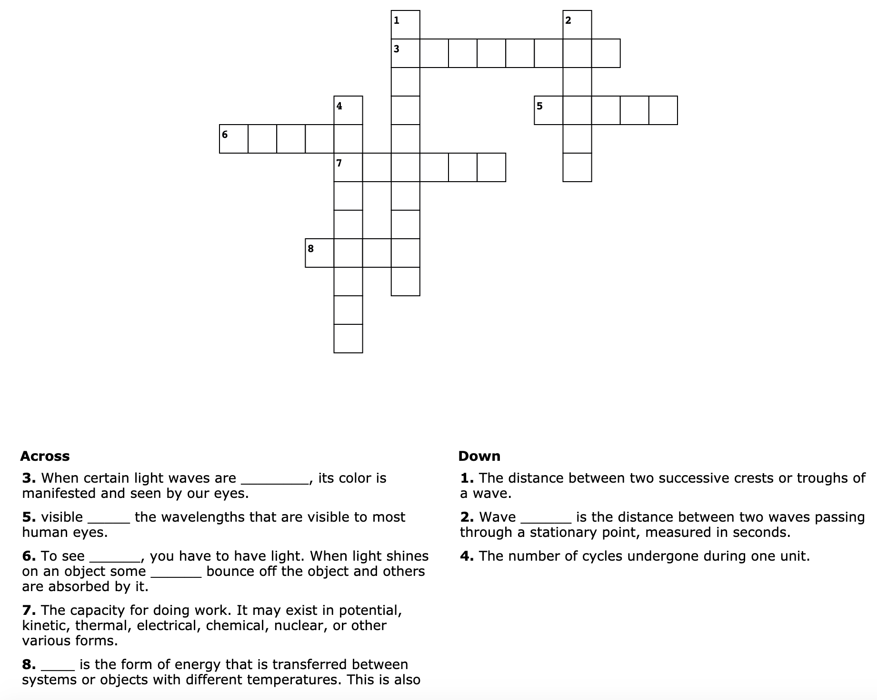
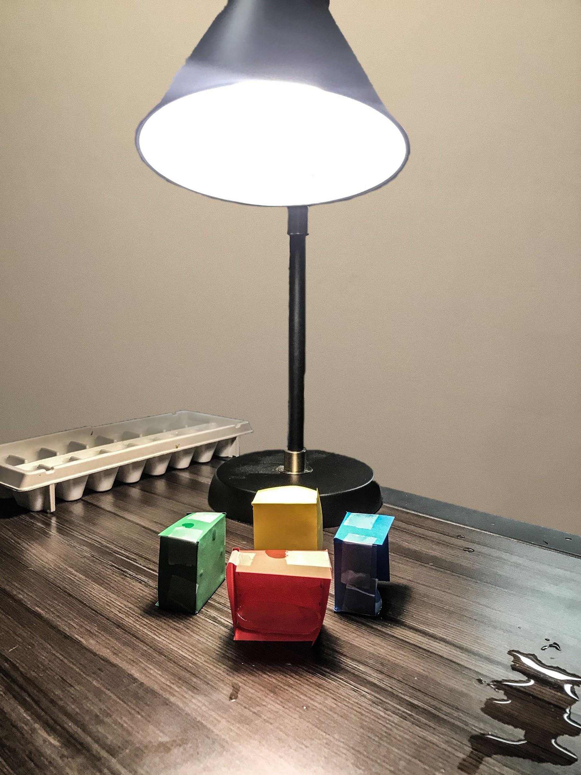

Experiment

Using the template provided, cut and fold the colored papers into cubes and place equidistant from the source of light. Leave one side of each cube open and place a single ice cube inside. Record the time it takes for each ice cube in each box to melt and record this data in the table below.

Box Color | Time
 | (min/s)
 | (min/s)
 | (min/s)
 | (min/s)

After performing the experiment, answer the following questions:

- What color melted the fastest? Why?

- What color melted the slowest? Why?

- Why do you think the colors made a difference in how fast or slow the ice melted?

Explain:

- What was the experiment and what were you looking for?

- What were the steps of the experiment?

- What did you observe? Why do you think that this occurred?

- Why are the things you learned about during this activity important?

Box Template
(Cut this out to trace on each piece of colored paper.)

