Introduction and Activity
All matter is made of constantly moving particles called atoms. The three states of matter (solid, liquid, and gas) depend on the movement and closeness of these atoms. In a solid, the atoms are packed together and move slowly in place. In a liquid, the atoms are loosely connected, take the shape of their container, and move past each other freely. In gaseous form, the particles move quickly and are far apart. They also take the shape of their container.
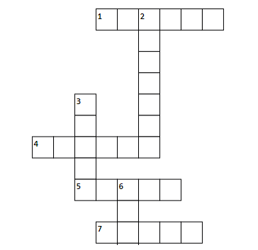
Across:

2. Oxygen is an example of a ___________.
4. Atoms in a solid move __________.
6. Ice is an example of a ___________.
7. Liquids are the same ________ as their container.

Down:

1. Atoms in a gas move ______.
3. Rainwater is an example of a ________.
5. The tiny particles that make up matter.
Plan and Carry Out
The demonstration will depict the ideas expressed in the introduction using household objects. It will involve blue beads, a large sandwich bag (i.e. Ziploc), a large bowl, and an empty milk jug with a cap.

- First, the demonstrator will fit as many beads as they can into the sandwich bag until it is completely full. They will seal the bag and then shake it. This represents the solid state.

- The demonstrator will then place a handful of beads into the bowl and then move it from side to side. This represents the liquid state.

- The demonstrator will place 3-5 beads into the milk jug, twist the cap on, and then shake it; this represents the gas state.

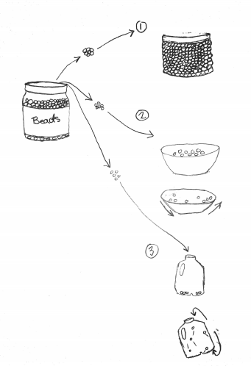
Collect Data
During the demonstration, please fill in the blanks.

Solid | Liquid | Gas
The atoms of a solid are  very ___________ together | Liquids ________ the  container that they are in | The atoms of a gas move  very ______
The atoms of a solid move  very _______ | Liquids move __________  than solids | The atoms of a gas are  _______ apart

Analyze Data

According to Particle Theory, what would the three states of matter look like in water? Draw the particles inside a block of ice, a glass of water, and a balloon full of steam.

Ice cube Cup with Water Balloon

Explain

Both the atoms in water and ice are close together, but if you pour them on a table, the ice keeps its shape and the water makes a mess. Why?

Both the atoms in water and steam take the shape of their container. However, if you open their containers, the steam escapes, but the water stays put. Why is that?

Ice is less dense than water, meaning it floats to the top. Why is this important to the survival of fish in freshwater ponds?

