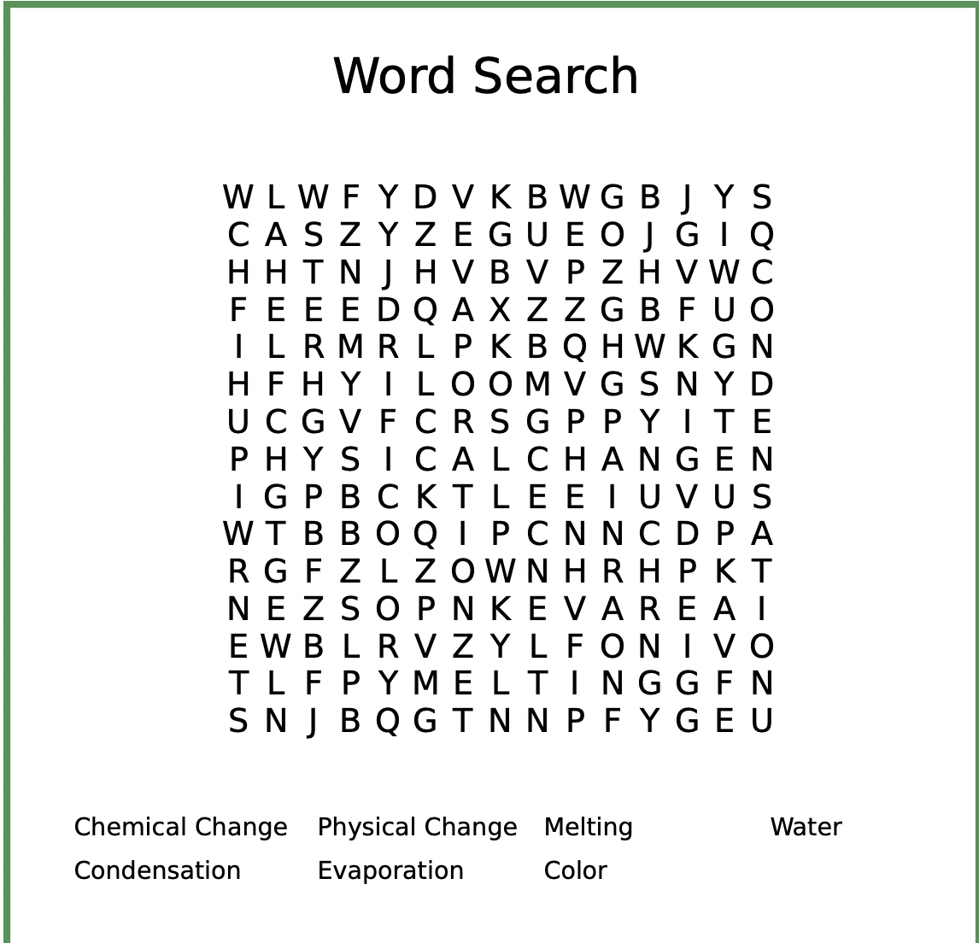
Paper Towels

Water glass 1
Empty Glass
Water glass 2

Record the state of matter of water in Experiment one for every time interval listed

State of matter
10 Seconds
30 Seconds
60 Seconds

Record the initial color of the water and then the color of the water after the experiment has taken place
 | Glass 1 | Glass 2 | Glass 3
Initial Color
Color after reaction

How many states of matter were shown in experiment 1?

Is a change in state of matter a chemical or physical change?

Was there a color change in Experiment 2?

Is a color change a chemical or physical change?

How does a physical change relate to the collection of water? How does a chemical change relate?

